

App User Guide

Index
The Primary Page 3
Main Interface Overview 3
Main Components 3
Instructions for the Navigation Buttons 4
Admin Page 5
Admin Dashboard Overview 5
Main components before browsing the admin page 5
Main Components 5
Statistics Page 7
Statistics Interface Overview 7
Main Components 7
Chat Assistant 8
Chat Assistant Interface Overview 8
Main Components 8
Search Result Page 9
Search Results Page Interface Overview: 9
Main Components 9
Design Notes 10
Important Notes 10

The Primary Page
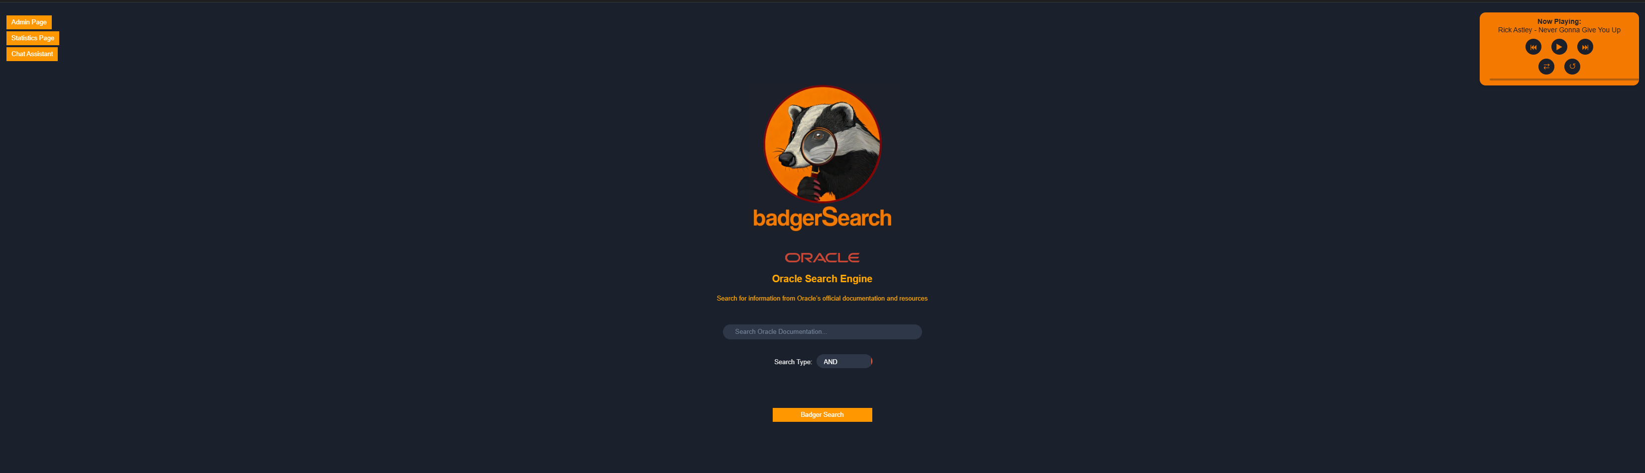

Main Interface Overview
This interface acts as the primary platform for browsing the application, giving users the ability to see statistics data, execute operational assignments, do searches, and play music. Quick access buttons for the "Admin Page" and "Statistics Page," a small music player, and a prominent search bar with possibilities for refining queries with an option of "AND" or "OR" for Boolean filtering are all included in its user-friendly, simplified design.

Main Components
Top Left Navigation:
Admin Page Button: Links to the admin page to provides access for editing indexes and music player.
Statistics Page Button: Links to statistical graphs based on data extracted from the database.
Chat Assistant Button: Links to a chatbot allowing for real-time chat for guidance and support.
Center Area:
Logo: Displays a badger with a magnifying glass, emphasizing the application's search focus.
Search Bar: Enables users to input search queries, accompanied by a dropdown list to select between "AND" and "OR" operators to apply Boolean filtering to the search results.
Search Button: A bold orange button labeled "Badger Search", used to start the search process.
Top Right Corner:
Music Player: Includes playback controls to listen to songs in the background while using the search engine.

Instructions for the Navigation Buttons
Admin page Button: Accesses the administrative panel.
Use: Click "Admin Page" to enter the Admin Page. Users will be required to insert a password prior to the page updating. Once the correct password is inserted, the user will be able to manage indexes and edit the music player’s playlist.
Note: The Password is: 123456
Badger Search Button: Initiates a search for specific queries.
Use: Click "Badger Search", after writing a query you want to search for, to perform a search. User will be moved to the results page displaying the query results.
Chatbot Assistant Button: Provides access to the chatbot.
Use: Click "Chat Assistant" to move to a page dedicated for conversing with the Chat Assistant.
Statistic Page Button: Provides access to the Statistic Page.
Use: Click "Statistics Page" to move to the dedicated page displaying various graphs depicting different data statistics.

Admin Page
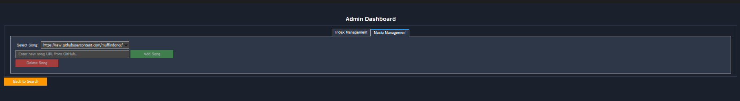
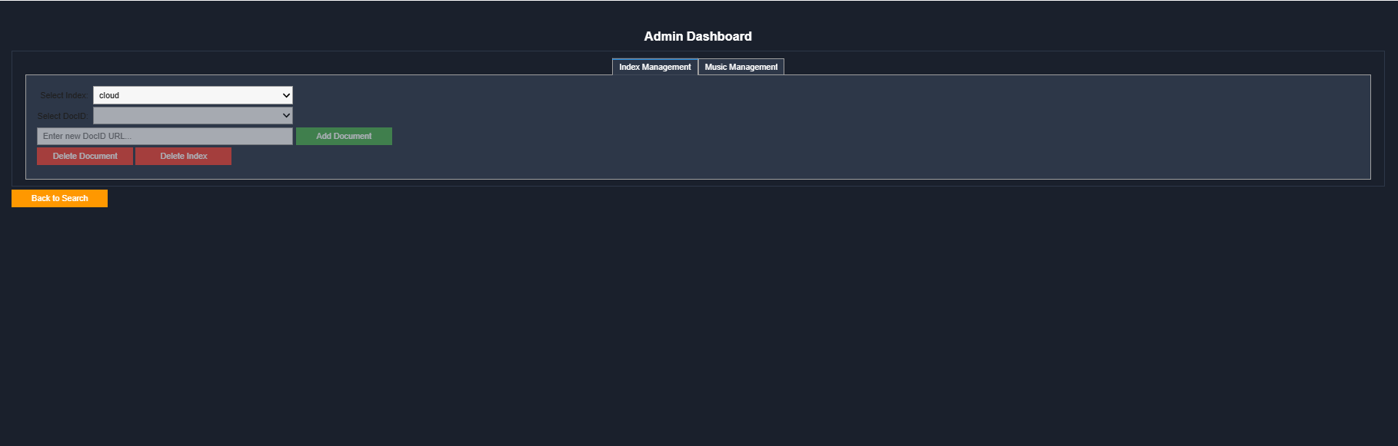

Admin Dashboard Overview
The Admin Dashboard allows to manage the indexes stored in the database and music player’s playlist. This interface is for the use of admins only and requires a password to access.

Main components before browsing the admin page
(After clicking button Admin page at the Main Page)
Center area of the main page at bottom:
Password Required Bar: Enables users to input password.
Submit Button: A bold orange button labeled "Submit" is used to check the password. If the password is correct, it opens the Admin Page. If the password is incorrect, an alert is displayed notifying the user of the incorrect password.
Note: The Password is: 123456

Main Components
Tab Navigation:
Index Management Tab: Displays tools for handling indexes and their documents.
Music Management Tab: Display tools for editing music player’s playlist.

Index Management Section:
Select Index Dropdown: Allows to choose an index from the database to edit.
Select DocID Dropdown: Provides the ability to select specific documents within the chosen index. Only becomes available once an index is chosen
Enter New Document URL Bar: Enables adding a new DocID by inputting the URL of a new document to be added to the selected index. Only becomes available once an index is chosen.

Action Buttons:
Add Document: A bold green button. Adds the entered document URL to the chosen index’s list of DocIDs in the database. Only becomes available once an index is chosen.
Delete Document: A bold red button. Removes the selected document from the index. Only becomes available once an index is chosen.
Delete Index: A bold red button. Deletes the currently selected index and all related data from the database. Only becomes available once an index is chosen.
Music Management Section:
Select Song Dropdown: Allows administrators to choose a song from the playlist.
Enter New Song URL Bar: Enables inputting a URL of a new song to be added to the selected songs.

Action Buttons:
Add Song: A bold green button. Adds the URL of a song entered to the ‘New Song URL bar’ to the media player’s playlist.
Delete Song: A bold red button. Removes the selected song from the media player’s playlist.

Navigation Button:
Back to Search: Returns the user to the main interface page.

Statistics Page



Statistics Interface Overview
The Statistics Interface to provides users with insights into search data, indexes and their frequency in Oracle’ webpages. It allows for the visualization of various metrics in different formats.

Main Components
Top Section:
Dropdown list: Allows the user to choose which metric they’d like to view. The default metric is ‘Top 10 Terms’ frequencies”, choosing a different metric will update the graph accordingly. There are several analysis options for the user to choose from:
Top 10 Terms Frequencies.
Top 10 Terms with Most URLs.
Top 10 Searched Queries.
Graph Type Selector: Enables users to choose between different visualization formats, color-coded and labeled to improve user’s understanding of the graphs. Default graph is presented as “Bars”, by clicking on a different option the graph’s presentation will be updated accordingly. The presentation options are:
Bar Chart.
Line Chart.
Doughnut Chart.

Navigation Button:
Back to Search: Returns the user to the main search interface.
Music Player (Top Right):
Features playback controls for added fun.

Chat Assistant

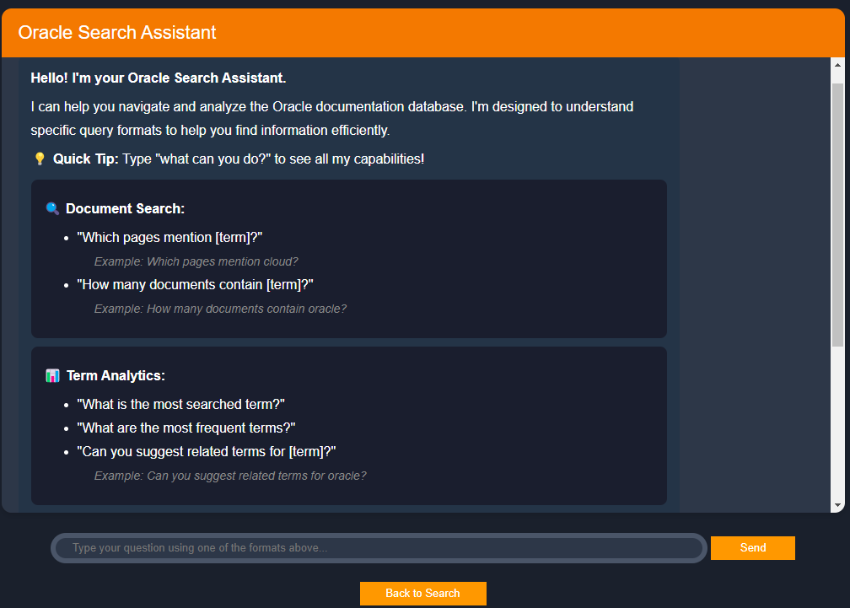

Chat Assistant Interface Overview
The chat assistant Interface is designed to provide users with an interactive tool to search for and analyze terms in Oracle-related documentation, the interface is simple and user-friendly, allowing users to communicate with the bot through a text area.

Main Components
1.Top Section:
The interface has a bright orange header labeled “Oracle Search Assistant”, ensuring clear purpose.
Instructional Panel Located centrally, this panel suggestions control on the features and capabilities of the assistant.

2.Ask me Bar:
Located at the bottom, enables user to input the question he wants, then press enter, so chat assistant will give the user the relevant information, and if it is not clear for the chat it will ask the user to write more clearly. Answers must adhere to the description provided by the chatbot.
3.Navigation Button:
Back to Search: Returns the user to the main search interface.

Search Result Page

Search Results Page Interface Overview:
After clicking "Badger Search" on the main interface page (with input in Search Bar, if the user didn't put input it will display an alert) the user is moved the Search Results Page which is designed to display the outcomes of a user’s search query, providing a summary of results and links to navigate through the results from the Oracle.
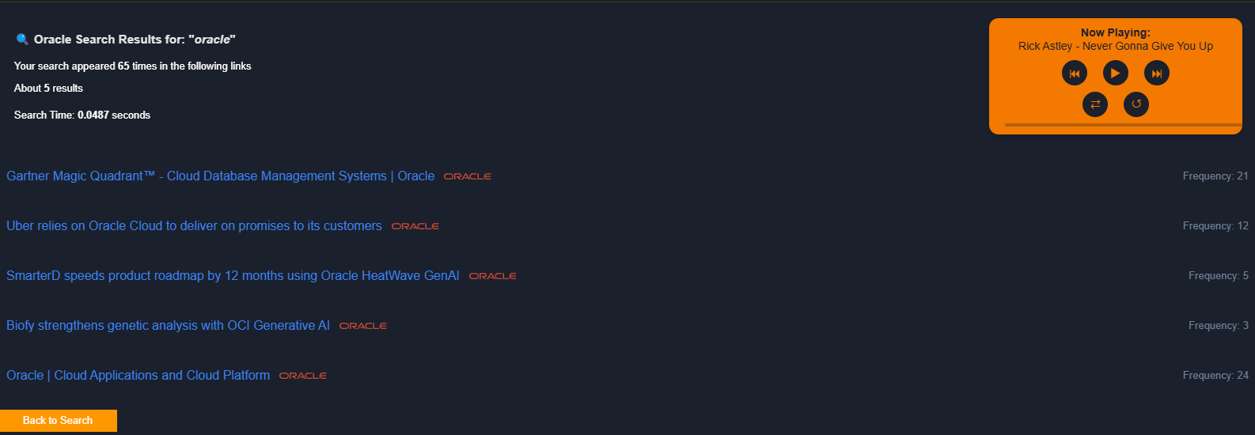

Main Components
1.Result Summary:
The page displays:
Message summarizing the results.
Total number of relevant results found.
List of visited links is provided based on the search query, and each link is with its frequency of appearance, shown on the right.
When the user clicks on link, a new page will open.
2.Top Right Corner:
Music Player: includes playback controls to listen to songs in the background during using the website.

3.Navigation Button:
Back to Search: Returns the user to the main search interface.

Design Notes
1.Color-Coding: Green is used for ‘adding’ actions, indicating creation or positive changes. Red is used for ‘deletion’ actions, signaling potential risks. Dark theme option in the website to reduce eye exposing to light and enhance focus.
2.Centerd Content: The panel and input bar are centered to maintain user focus and guide the interaction process.
3.Clear Instructions: The chatbot assistant’s capabilities are explicitly outlined, ensuring users know how to interact with the interface effectively. Text areas all include a message to help the user understand their purpose.
4.Real_Feedback: The chatbot assistant’s replies immediately to a user’s input and will alert them if their input is incorrect. Alerts for invalid or empty queries help the user understand the system and guide them towards valid inputs.

Important Notes
To access admin page, use the password ‘123456’
Tips for Effective Searching:
Use specific keywords rather than broad terms to increase the relevance of your search results.
If you don't find what you're looking for on the first attempt, try using synonyms or related terms.
If you enter incorrect or incomplete data, such as a wrong missing information, the system may not behave as expected. And it will alert of something wrong.
Interacting with the Chatbot:
Start by reading the initial message from the chatbot. It will often greet you and ask how it can assist.
Type your question or request in the message input field.
Be clear and specific in your messages to ensure the chatbot can provide accurate assistance.
After typing your message, press Enter to submit it.
The chatbot will respond based on the information it has, and you can continue the conversation as needed.

